“Adolescents Treatment Issues”

Members:

Bermejo, John Carlo

Demontano, Beatriz

Estil, Jonh Earl

Salvilla, Jhieryl

Christian Living Education

Grade 9G

Sir. Rainheart Pinuela

**Introduction of the members of the Group:**

**Bermejo** - *Konichiwa, My name is John Carlo C Bermejo im also an introvert that likes to keep silent about everything, I enjoy watching anime to pass time and I am also responsible, sometimes lazy when it comes to chores, I love to take care of my juniors and I really respect all my seniors. My Contributions to this performance task were typing, helping editing the document and answering some questions.*

**Demontano** - *Hi my Name is Bea Demontaño. I am an ambivert both extrovert and introvert. I'm a sweet person and I give love to other people. I'm not smart but wise and hardworking. And cute :). I’m also a mean person, but thanks to my heart I’m kind to other people. My contribution in this group is the Rationale and helped with the solutions.*

**Estil** - *Hello, my name is Jonh Earl Estil, and I am an introvert who is nice, goes with the flow, and I am not killjoy. I enjoy singing and dancing, and I am a dedicated student who puts in great effort in all of my assignments. Editing the webpage, documents, and several grammars were among the efforts I made to this performance task.*

**Salvila** - *Hi I am Jhieryl Salvilla a cheerful person, short tempered, sometimes lazy, fun and sweet. As a student I'm not a hardworking student, but I do every task with great effort. My contribution to the group is answering the objective and benefit part.*

* **Objectives and Beneficiaries:**

The objective of this is to lessen the online gaming addiction, because young kids nowadays are very addicted to online gaming. They abandon their healthy lifestyle, they don't eat on time anymore and don't take proper hygiene. According to a website, online gaming addiction is considered a mental health condition. Most teenagers are affected by this due to the internet that has been famous throughout the world. We should lessen our screen time, by doing what's right young children can have a better lifestyle. It can also benefit the parents so that parents will not be worried anymore about their children.

**Introduction of the chosen Issue: (Online Game Addiction)**

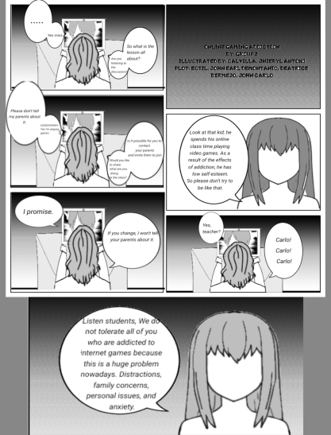

Online game addiction is one of the problems for students, online games cause students to lose focus on studies and track of time. However video games are designed that way, to be addictive where you can't stop playing until you are satisfied with your gameplay. Gaming provides an endless and constantly changing play experience, often in a social context, and there are new gaming products and innovative technologies continually entering the consumer market. Many new games include features that make them more immersive, socially integrated, and monetized than those before them. However, while there can be many benefits associated with gaming, there is also growing recognition that unrestricted screen time, particularly in younger people, can lead to harm and that gaming can be highly time-consuming and addictive for some vulnerable individuals

* **Background of the Issue**

Online game addiction also known as gaming disorder or internet gaming disorder, is generally defined as the problematic, compulsive use of video games that results in significant impairment to an individual's ability to function in various life domains over a prolonged period of time.

* **Root Causes**

Video games are designed to be addictive using state-of-the-art behavioral psychology to keep you hooked. Games are immersive experiences that provide you with a high amount of dopamine, and overexposure to this level of stimulation can cause structural changes to your brain. You begin to live in a world where you expect instant gratification. Games are so immersive that it’s easy to play for hours and hours without even noticing that a minute has gone by. They allow you to escape and see measurable progress.They are social and create an environment where you feel safe and in control.

* **Stand of the Church:**

Video games simply magnify many of these works, conditioning youth to think that this is normal and acceptable. Teenagers in God’s Church must do everything in their power to avoid those things that fuel their carnality which include almost every video game on the market today.

**Rationale**

We chose this topic, because it can give a lesson and realization to other people .

They can learn something in this advocacy project and that is the reason why this advocacy project is important for people who are addicted to online games and also people who are addicted to the internet. It can give a realization that Online games can’t control your mind, but you yourself . This is to open the people’s eyes that the world doesn’t revolve around gadgets and online games. They also need to realize that time always runs .Moreover they should know that life is short to be wasted in just playing online games all day just to satisfy our eyes. More importantly this might give them a big opportunity to change themselves and learn to value life with God. Our chances to change are not limited as long as we live, so we choose the right choices for ourselves to be better. This can change their perspective in life to spend more time with God than their phones. We all know that it is hard to avoid temptation of what we really want . To change ourselves to be better, maybe this advocacy can be a little help to reach God and be with him throughout our journey on changing ourselves to be better.

* **Significance of the Study**

Various studies show that playing too many computer games causes physical damage and increases anxiety and depression in players. Many studies show that most adolescents who are addicted to computer games have high heart beat and blood pressure due to too much excitement and stress. This study may give information to the students about how online gaming affects the life of a student. This study is significant to the family because it may help them to know if their children are addicted to online games.

**Solutions**

1.Set a limit to yourself in using your gadgets and help yourself to follow them

2.Keep phones and other gadgets out of the bedroom

3.Do some exercise. This will lower the health risks of sitting and playing for long stretches of time.

4.Try to read books that you're interested in.

5.Watch movies or play with your pets.

6. Spend more time with your family.

7. Spend more time with God.

8. Find hobbies that can entertain yourself like physical activities.

**Prayer and Acknowledgements:**

* **Prayer**

We thank you, Almighty God, for all of your gifts to us in creation. We acknowledge the abilities we have been given, the resources we have at our disposal, and the opportunities we have to help others. We appreciate your expertise, intelligence, and cooperation in completing the task. We appreciate the contributions of teachers and group members to the school and activities. May our gratitude for you be evident in everything we do. Help us to carefully use all of your gifts for the greater benefit, knowing that our everyday effort contributes to your loving purpose; through Jesus Christ, our Lord. Amen.

**References:**

**<https://www.sciencedirect.com/topics/nursing-and-health-professions/game-addiction>**

**<https://gamequitters.com/video-game-addiction>**

**<https://www.psychguides.com/behavioral-disorders/video-game-addiction>**

**<https://pointguardsite.wordpress.com/2017/03/10/effects-of-online-game-addiction-to-the-students-of-the-senior-high-school-students-of-southern-christian-college>**